A Guide to Creating a Mental Health Policy for your School
Contents
Where should you start?
What is a MH Policy for Schools?
Why have a MH Policy?
What other policies does it link to?
What should be in it?
Who should be involved?
How will it be implemented / made a ‘living resource’?
Useful links / resources
Sample Policies

Where should you start?
With a Whole School Approach to wellbeing
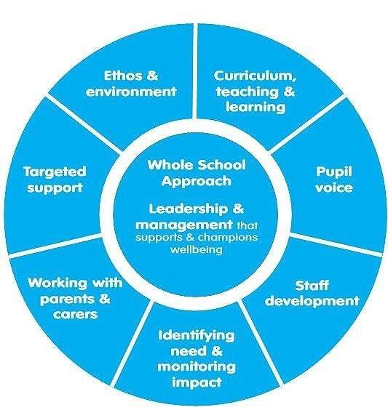
Promoting children and young people’s emotional health and wellbeing: A whole school and college approach. Public Health England 2015 (www.headstartkernow.org.uk/sec-sch-support/universal-/)

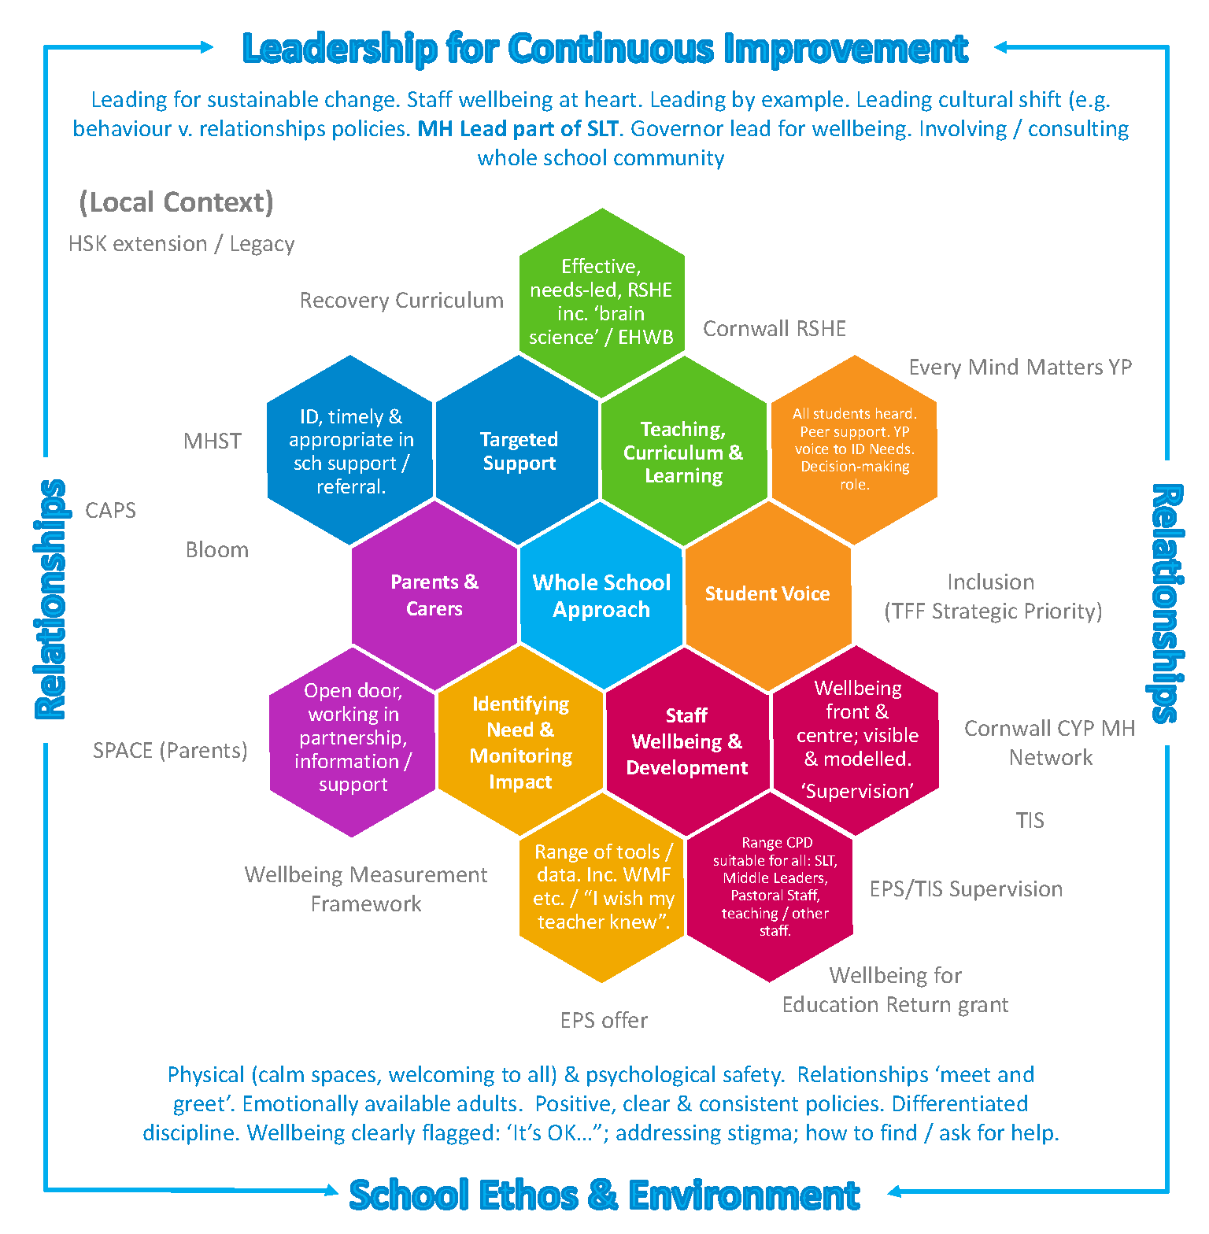

What is a Mental Health Policy for Schools?
It is not statutory so why have one?

Why have a MH Policy?
It is the JD / route map for a MH Lead…

What should be in a MH Policy?
Roles and responsibilities and key contacts
What is MH?
Understanding of some MH issues e.g. anxiety; low mood / depression; self-harm; eating disorders; OCD
Recognising need
Graduated response
- Universal: whole school – all staff / learners
- Targeted: support in school
- Specialist: partnerships with families and external agencies
Provision mapping and individual support plans / pupil passports etc.
If I’m worried about a child… easy ways for everyone (staff / students / parents) to know how to support / signpost to the right people in school.
Mental Health Education in the Curriculum
training for staff and students e.g.
- Trauma informed practice
- Emotion Coaching
- MH First Aid
- Youth MH First Aid
- Peer Support
- Suicide Awareness
- Etc. as appropriate to needs of schools
Transitions: into / within / out of the school – as appropriate
Evaluating / Measuring Impact of the Policy e.g. using tools like the WMF / I wish my teacher knew
And:
Links to other policies
- Behaviour / relationships - relationships are key. Need a relationships policy or element (not bolt on) in the behaviour policy
- Safeguarding
- SEND
- Equality / Diversity
- Nurture
- Anti-Bullying
- Self-harm
- PSHE
- Transition
- Staff wellbeing
- Teaching and Learning
It is important that there is a consistency and coherence across all policies. The most obvious example being a ‘draconian’ ‘no excuses’ Behaviour Policy with isolation as a core strategy.

Who should be involved?
Everyone. There needs to be a Whole School Approach so everyone needs a voice including the hardly reached students / families
SLT / all school staff / governors
YP / Parents / School Nurse
MHST workers / CAPs where appropriate
Education Psychology Service
External Agencies
Feeder schools / clusters / MAT schools
Top Tips
Notes to assist when creating a policy for your setting:
- Don’t make it too lengthy, keep it concise and practical – easy to use
- Involve students, staff and parents/carers – invite them to contribute and offer their feedback
- Ensure key members of staff are named so colleagues know who is responsible for what and how concerns can be reported
- Set an annual date to review the policy, and ensure it’s updated should any changes to staff etc. take place.
- Ensure the policy is accessible – communicate it well internally and make it available for students and parents/carers to view

Sample Policies
https://www.headstartkernow.org.uk/mh-leads
https://www.headstartkernow.org.uk/mh-policies

Further Reading / useful links
The Cornwall Educational Psychology Service
The EPS are developing work around relational policies alongside other aspects of their service. Contact your EP to find out more.
Tina Rae
The Wellbeing Toolkit for Mental Health Leads: A Comprehensive Training Resource to Support Emotional Wellbeing in Education & Social Care
Dr Tina Rae, Dr Amy Such & Dr Jo Wood
Including a module entitled: The Role of the Mental Health Lead: Developing a whole-school policy to support the wellbeing of pupils and staff.
http://www.hintonpublishers.com/isbn_template.php?isbn=978-1-912112-65-4

Developing an Attachment Aware Behaviour Regulation Policy
https://ww3.brighton-hove.gov.uk/sites/brighton-hove.gov.uk/files/Behaviour%20Regulation%20Policy%20Guidance%20-%20Sep%2018_1.pdf

Guidance for Developing Relational Practice and Policy
https://www.babcockldp.co.uk/inclusion-and-ehwb/relational-learning
https://www.babcockldp.co.uk/babcock_l_d_p/Core-Downloads/Covid/Back-to-School/vlog5/Guidance-for-Developing-Relational-Practice-and-Policy.pdf
EPS
Louise Michelle Bombèr (https://touchbase.org.uk/)
“Know Me to Teach Me: Differentiated discipline for those recovering from adverse childhood experiences”, Louise Michelle Bombèr 2020 (https://touchbase.org.uk/publications/)
This is a truly outstanding book. A must read. Includes a sample relational policy to adapt.
Paul Dix
When the Adults Change, Everything Changes: seismic shifts in school behaviour, Paul Dix
https://whentheadultschange.com/
Again simply outstanding!
Pooky Knightsmith
1. Whole School Approach
The Mentally Healthy Schools Workbook by Dr Pooky Knightsmith
How Mentally Healthy is Your School? A Simple Audit by Dr Pooky Knightsmith
2. MH Policy guidance and template:
https://www.pookyknightsmith.com/post/school-mental-health-policy-guidance
Short You Tube Video: Writing a MH Policy https://youtu.be/y-4cqYWvrkk
Anna Freud
https://www.annafreud.org/schools-and-colleges/5-steps-to-mental-health-and-wellbeing/leading-change/ensure-there-is-a-robust-mental-health-and-wellbeing-policy/
TIS UK
Practitioners will have been provided with a sample relationships policy and some additional guidance docs based on their TIS training.
Governors’ Resources
https://governorsforschools.org.uk/wellbeing-governors/external-mental-health-wellbeing-resources/
https://www.nga.org.uk/Knowledge-Centre/Pupil-success-and-wellbeing/Pupil-wellbeing/Mental-health/Promoting-positive-mental-health.aspx

