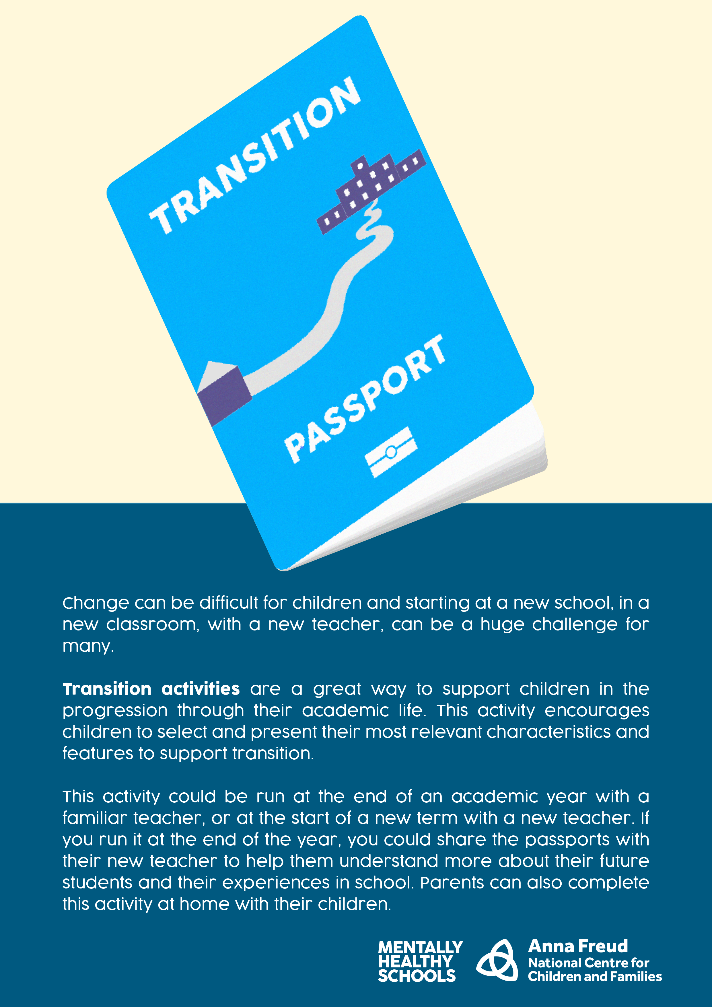

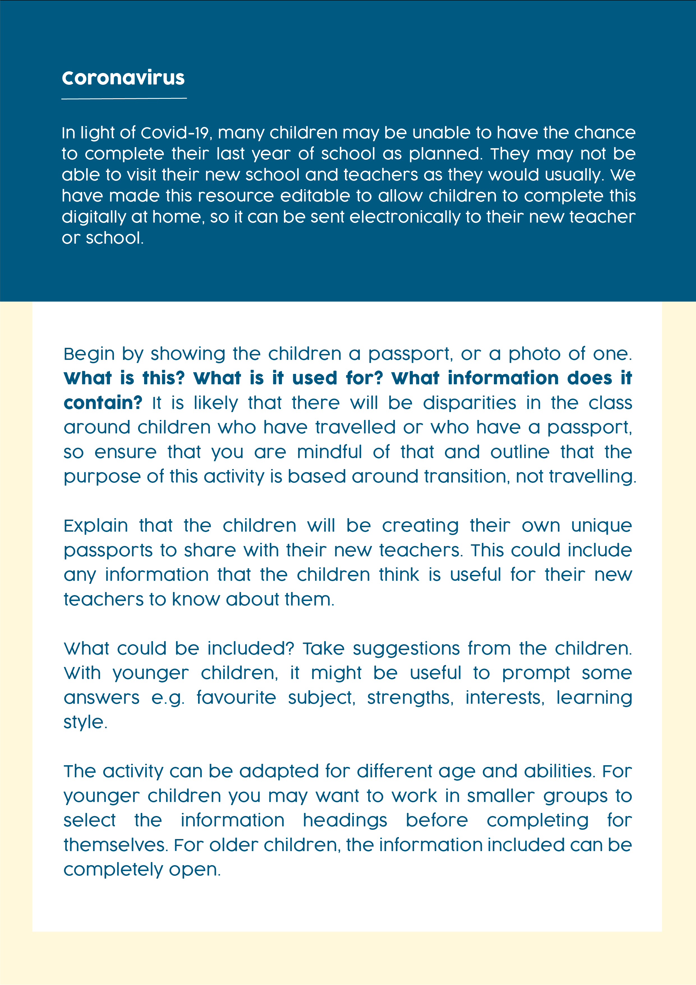

v

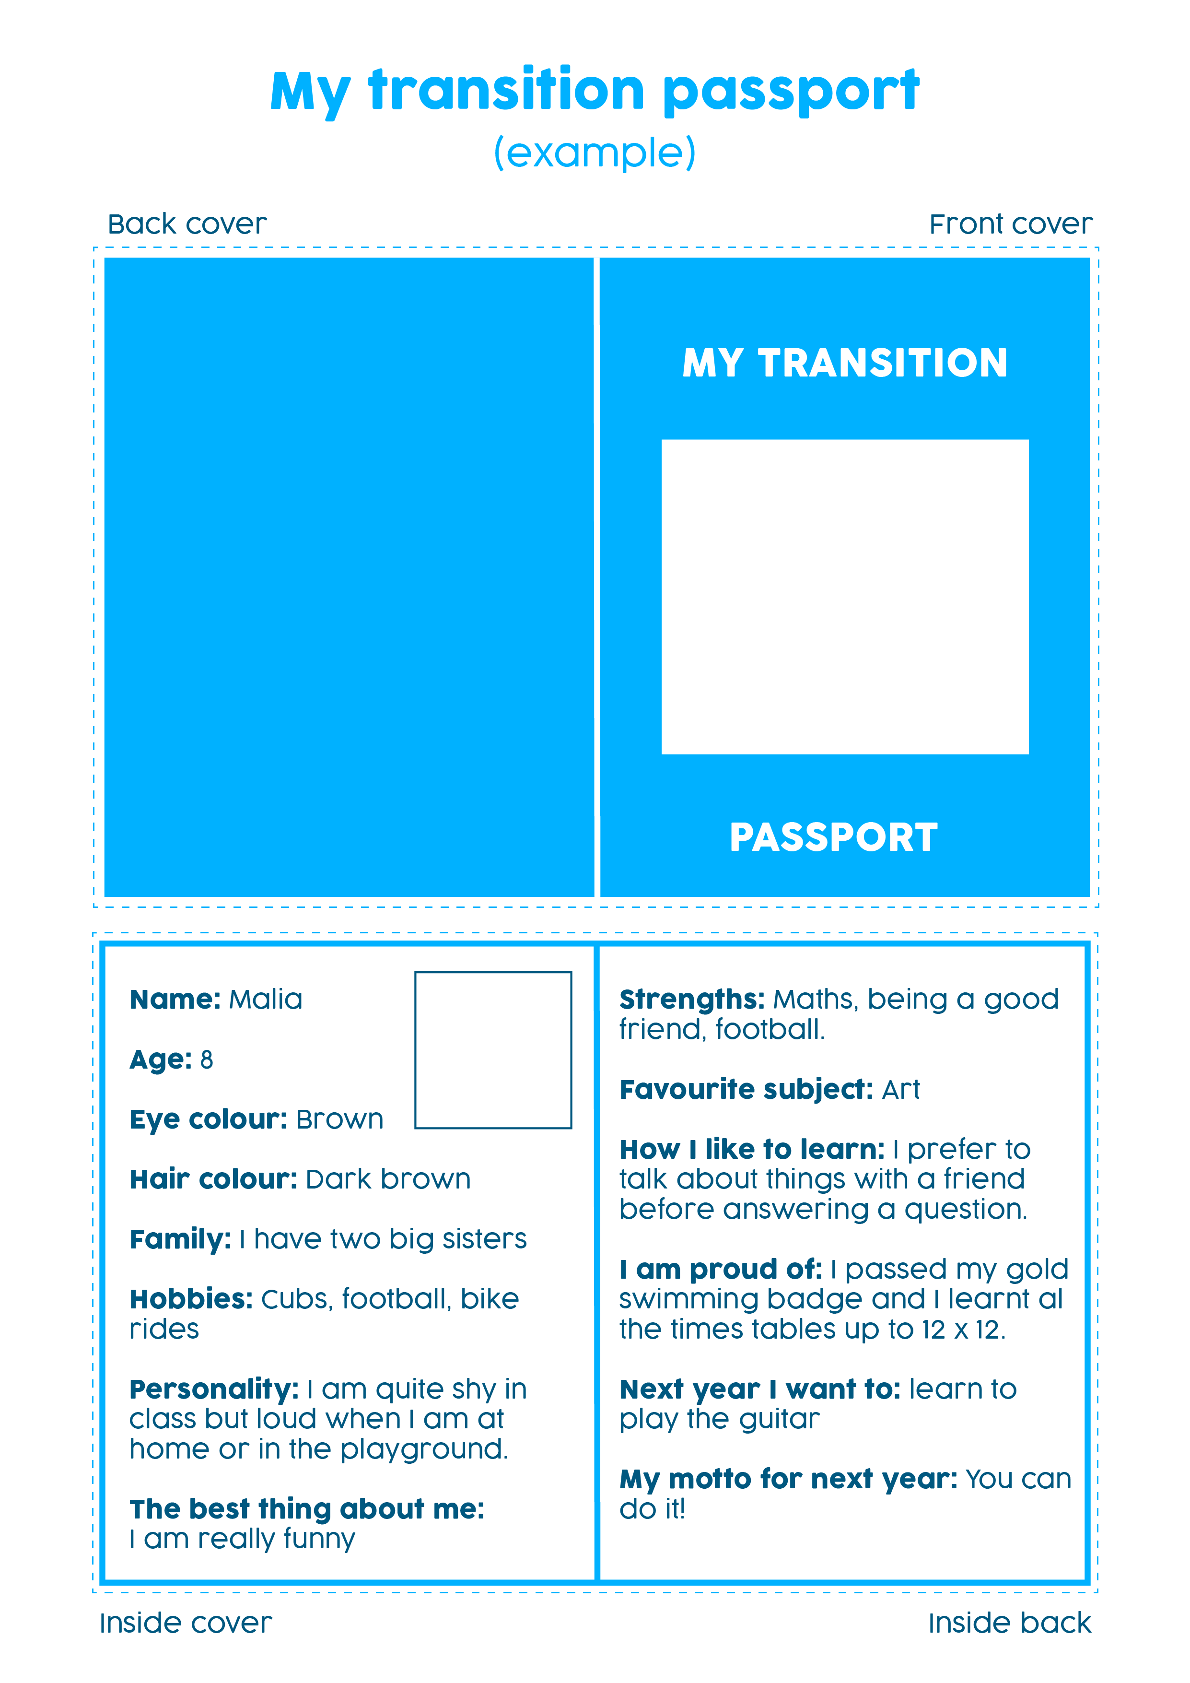

005880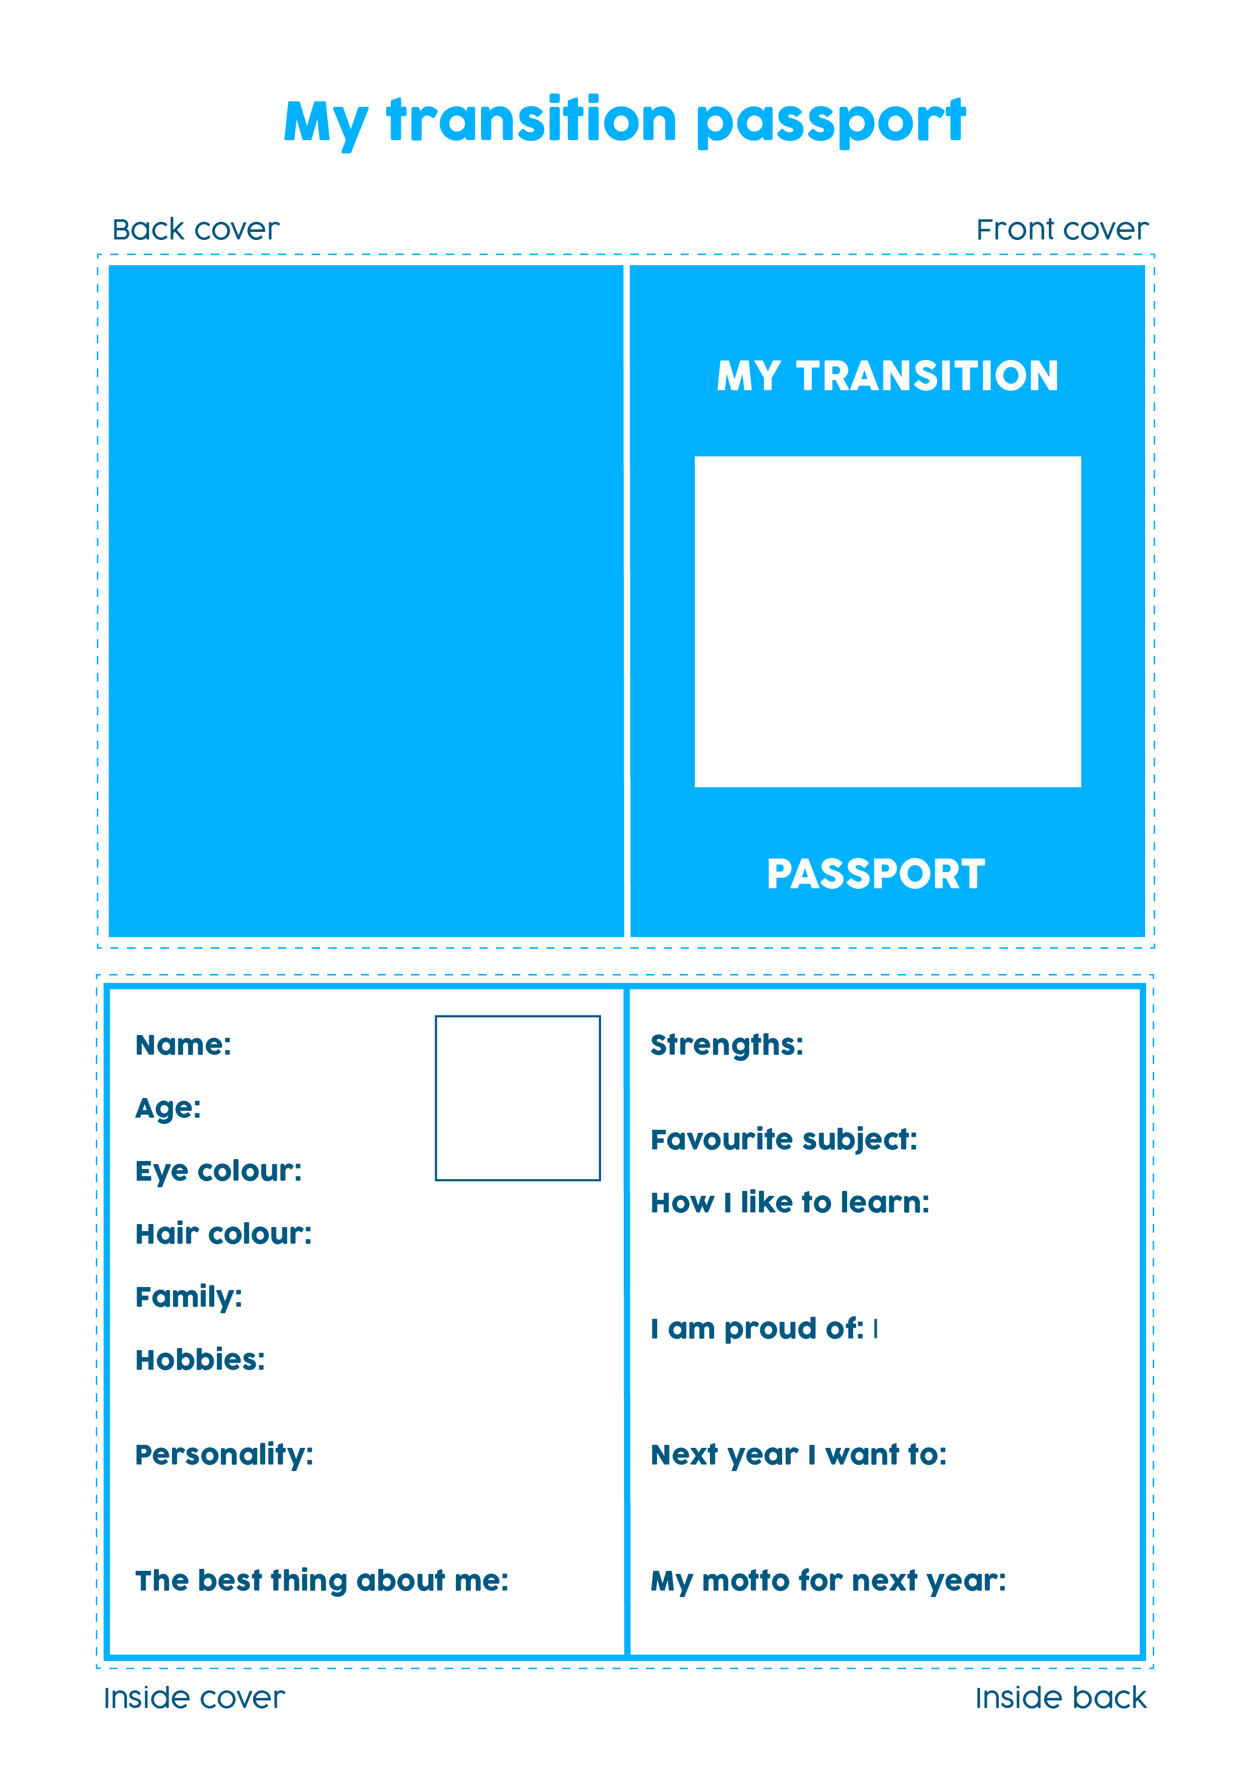

Name:

Age:

Eye colour:

Hair colour:

Family:

Hobbies:

Personality:

The best thing about me:

Strengths:

Favourite subject:

How I like to learn:

I am proud of:

Next year I want to:

My motto for next year is:

