Relational Approaches when understanding and supporting children. Chantel Yeates

* 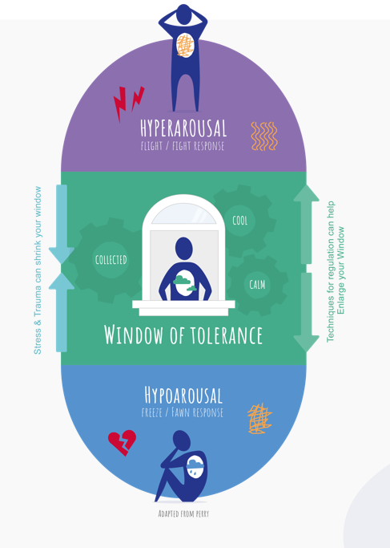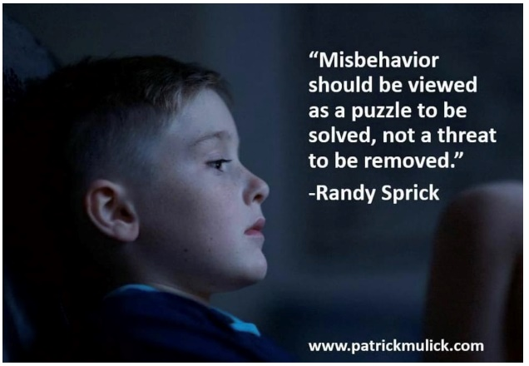 Circles for all
* Meet and Greet
* Noticing
* Being curious
* Active listening
* Building trust
* Caring

Building relationship, understanding emotions, supporting with regulation of emotions increases the window of tolerance.

* Connection
* Belonging
* Interventions

